

HOW TO USE FREERTOS WITH THE FRDM-KL25Z IN MCUXPRESSO

Advanced Embedded Systems

Authors: Dr. Gilberto Ochoa Ruiz

Msc. Jorge German Perez Blanco

Contents

Introduction: 2

Environment set up: 2

Installing the SDK in the IDE 5

Create a project from one of the examples shipped with the FreeRTOS middleware. 7

Modifying and running the example on the board 11

How to import and run projects created on another pc to your workspace 16

# Introduction:

FreeRTOS, or Real-Time Operating System, is of paramount importance in the field of embedded systems and real-time applications. It plays a pivotal role in ensuring the efficient and deterministic operation of microcontroller-based systems by providing a lightweight, open-source, and highly configurable real-time kernel. FreeRTOS enables developers to manage tasks, scheduling, and synchronization in a reliable manner, making it essential for applications where timing precision, responsiveness, and resource management are critical, such as in aerospace, automotive, medical devices, and IoT. Its widespread adoption and extensive community support have made it an indispensable tool for engineers and developers striving to achieve real-time performance and reliability in their projects, ultimately contributing to the advancement of technology across various industries.

In this tutorial we are going to learn how to configure the IDE MCUXpresso, developed by NXP, manufacturer of the Freedom Development Board FRDM-KL25Z, to use the FreeRTOS operating system and run a simple application to verify that the procedure was successful.

# Environment set up:

The first step is the installation of the IDE (MCUXpresso) and the Software Development Kit (KSDK) downloaded from the manufacturer's site. It's worth noting that you must create an account before you can access any downloads on the manufacturer website.

The IDE can be obtained through the following link:

<https://www.nxp.com/design/software/development-software/mcuxpresso-software-and-tools-/mcuxpresso-integrated-development-environment-ide:MCUXpresso-IDE?tid=vanMCUXPRESSO/IDE>. Scroll down until you reach the download section (see next picture). Hit the download button beside the IDE’s name. Then select the version, according to your host computer Operating System.

The KSDK can be obtained through the following link: <https://mcuxpresso.nxp.com/en/welcome>. Click on “Select Development board” option (see next picture).

Then you must select your board, type on the filter the next string: “FRDM-KL25Z” and choose the first option (see next picture).

Then hit on the “Build SDK” button as shown in the next picture.

Next you can select all the middlewares that you need to install with your SDK, you must include FreeRTOS and finally click on the “Build SDK” button (see next picture).

c

Next, you must hit on the “Download” button as shown in the next picture.

c

Finally, hit on the "Download SDK Archive” option as shown in the next picture.

c

# Installing the SDK in the IDE

The installation process of the IDE is straightforward. You just need to make sure to have Administrator access in the user running the installation and accept all the drivers installation prompts.

First time you run the IDE you’ll be prompted where you want to start your workspace. This will be the default location for your new projects (see next picture), hit the “Launch” button to start the IDE.

c

Once on the IDE you must change your view to “Develop Perspective”. To do that you must follow the path shown in the next picture. You can also hit on the “IDE” button, if shown, the next screen should be the same regardless of the option you chose.

c

c

c

c

In the next screen you must make sure to select the “Installed SDKs” tab as shown in the next picture, and then drag and drop the zip file with the SDK that you downloaded in the previous step to the highlighted area.

c

Next, you’ll be prompted with the window shown below and you just need to simply hit the “OK” button.

c

Now the SDK should be installed, and you can create a new project from one of the examples shipped with the FreeRTOS middleware and then edit it to your custom code.

# Create a project from one of the examples shipped with the FreeRTOS middleware.

From the Develop Perspective you can access the “import SDK example” wizard by hitting the button shown on the next picture.

cc

If you’re on the welcome page, you can access the “import SDK example” wizard by hitting the button shown on the next picture.

Then hit on the “Go straight to the Wizard...” button as shown below, either path you chose will lead you to the wizard.

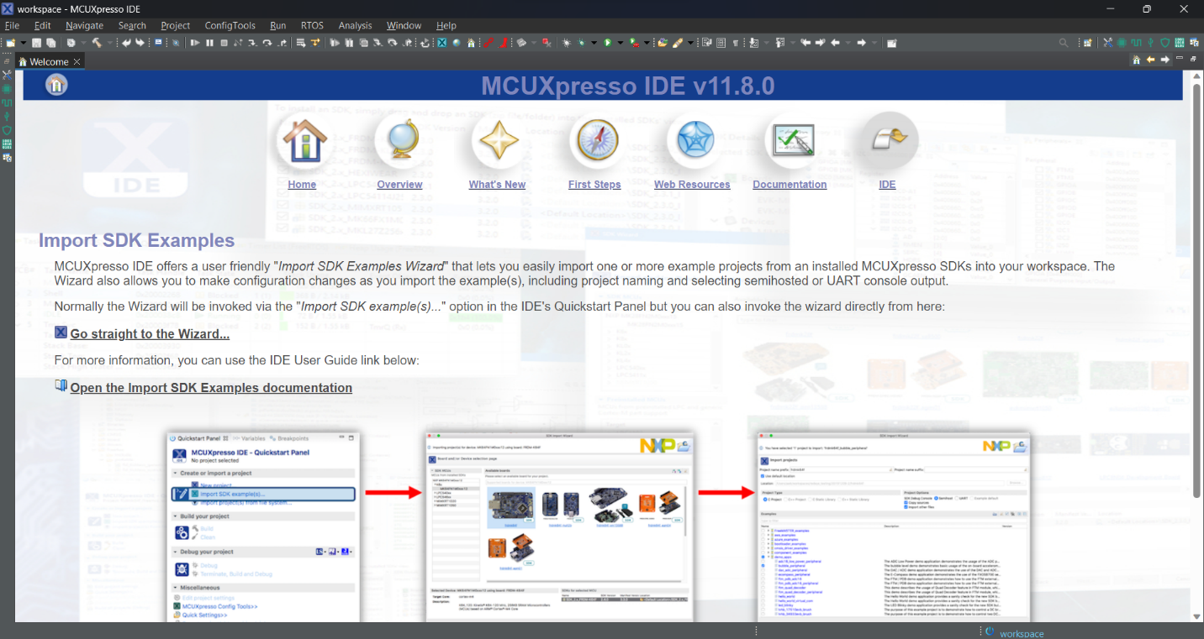

On the first screen of the wizard, you should select the board (FRDM-KL25Z) and then hit the “Next” button, as shown in the picture below.

On the second page of the wizard, you must select which example you want to import, the name and suffix of the project that will be imported to your workspace. In this example we are going to choose the hello example, one the simplest ones (see next picture). Once you’ve selected all the previous options you can hit the “Next” button.

On the last page of the wizard there are some config options that we are not going to tune right now so just simply click on the “Finish” button as shown in the picture below.

# Modifying and running the example on the board

To edit the code, from the Develop Perspective, you must double click on the file that contains the previous code. For this example, this file is called “freertos_hello.c ”, and it can be located on the “source” folder within our project file in the workspace (see picture below for reference). On the central area of the window, the file should be able to be edited.

To use the LEDs included on the board we need to configure the pins for that end. To do that we are going to use the pin configuration wizard. To access that wizard, from the Develop Perspective, we need to click on a little button shown in the next picture, located on the right up corner of the tools bar.

The pins associated with the red and green LEDs of the board are both connected to port B and to pins 18 and 19 respectively. So, we need to select then and configure their parameters (see picture below for details). You can start by writing the string “GPIOB 1” on the filter label as shown, and then select each pin with the right function. Make sure to click on the cells of the column labeled as GPIO, as shown, once done, both pin cells should be green as the “GPIOB:GPIO,18” cell shown on the picture. There should also be an entry for each one on the bottom tab of the window, as shown for the “GPIOB, 18”.

Now we are going to configure the parameters for both pins, as follows: “Direction” should be set to “Output” and “GPIO initial state” should be set to “Logical 1”, all other parameters should be left to their default state. Now to end the pin configuration and to export the initialization code to our project we need to hit the “Update Code” option located on the central region of the tools bar. All the configurations described are depicted in the next picture.

Finally, a confirmation prompt of the changes will pop up, you can review them and then click on the “OK” button.

Now we are going to change the application code to run a task that will control the red and green LEDs in a predefined way. As this is the only task, it will run in an infinite loop. The proposed changes are located on line 79 of the code. We are going to comment on lines 79 and 80 and add our code. The resulting code is shown in the picture below.

To program the board and debug the application you must follow the path shown in the next picture, to enter the Debug Perspective. Make sure to connect the board to your pc before entering the Debug Perspective and that the board drivers are already installed.

By default, the Debug Perspective starts with the microcontroller halt in the first line of code, as there are no other breakpoint already set on the project, if you hit the “Resume” button (located on the central portion of the tools bar) the code will start running on the board, and you should see the LEDs blinking (see picture below to more details).

# How to import and run projects created on another pc to your workspace

To execute the examples seen in class, you must install some software that allows communication with the serial port of the FRDM-KL25Z board. The software selected in this case is Tera Term, a binary release of Tera Term can be downloaded through the following GitHub link:

<https://github.com/TeraTermProject/osdn-download/releases>

You must select the executable to download (file with .exe extension). The installation process is simple, just leave the default options and press next on each of the wizard screens.

To check the correct operation of the examples, you must open the serial port on Tera Term and ensure that its configuration is the same stablished on the examples. Once you open Tera Term app and the board is connected to your pc you should see the window shown in the next picture.

You must select the serial check box and then the appropriate serial port from the drop down menu as shown in the previous picture, the string that identifies the serial port from the board should include “OpenSDA – CDC Serial Port”. Finally click on the “OK” button.

Now you must establish the appropriate configuration for the serial port, to do that, you must follow the path shown in the next picture.

Then the serial port configuration window should appear, you must establish the configuration parameters as shown in the next picture and finally click on the “New setting” button. Probably the only setting you must change is the speed and set it to 115200. The configuration can also be checked in the [README.txt](https://drive.google.com/file/d/1thFnaZn8u9dvUIVhIwvIQEY8hBWbiVkB/view?usp=drive_link) file included in the examples folder

To import and run projects created on another pc to your workspace you must click the “Import project(s) from file system…” button as shown in the next picture.

The first window of the “Import project(s) from file system” wizard is shown in the next picture. If you have downloaded the example folders from google drive then you should have a zip file containing the project, or projects if you selected more than one. In this case you must select “Project archive (zip)” option as shown in the picture. The other import options will not be covered in this tutorial.

Then simply select the zip file that contains the examples you want to import, and it will show the path on the wizard, click on the “Next” button to continue with the wizard as shown in the next picture.

Finally, in the next window of the wizard, you must select the examples that you need to import and click on the “Finish” button as shown in the next picture.

